Course Specialist Year 12 Test Three 2022

Student name: ________________ Teacher name: ________________

Task type: Response

Time allowed for this task: _____40______ mins

Number of questions: _____6______

Materials required: NO classpads nor calculators

Standard items: Pens (blue/black preferred), pencils (including coloured), sharpener, correction fluid/tape, eraser, ruler, highlighters

Special items: Drawing instruments, templates, notes on one unfolded sheet of
A4 paper, and up to three calculators approved for use in the WACE examinations

Marks available: __40____ marks

Task weighting: _10___%

Formula sheet provided: Yes

Note: All part questions worth more than 2 marks require working to obtain full marks.

NO classpads nor calculators!
Q1 (3 & 3= 6 marks) (3.3.9-3.3.10)
- Solve the following set of linear equations.

Solution
Specific behaviours
eliminates one variable from two equations
eliminates two variables from one equation
solves for all 3 variables

- Consider the system below,

Determine the values of such that there are:
- Unique solution
- Infinite solutions
- No solutions.

Solution
Specific behaviours
eliminates two variables from one equation
determines values for uniqueness
determines all values for infinite and no solutions

Q2 (2, 2, 2 & 3 = 9 marks) (3.3.11, 3.3.13)
A particle moves such that at time seconds the velocity is . The particle is initially at the origin.
Determine:
- The position vector at time second.
Solution
Specific behaviours
integrates and states a constant C
states r with t=1

- The acceleration of the particle at second.

Solution
Specific behaviours
diff v
states with t=1

- The speed of the particle at seconds.

Solution
Specific behaviours
determines velocity at t=2
determines speed, no need to simplfy

- The times when the velocity is perpendicular to the acceleration.

Solution
Specific behaviours
uses dot product
equates to zero
states one non negative result

Q3 (4, 3 & 2 = 9 marks) (3.3.12, 3.3.13, 3.3.15)
Consider a particle that is projected from the top of a cliff of height 30 metres with a speed of metres per second at an angle of to the horizontal. Assume that the acceleration is constant at towards the centre of the Earth. Let the origin of cartesian axes be at the base of the cliff as shown below with the appropriate unit vectors .

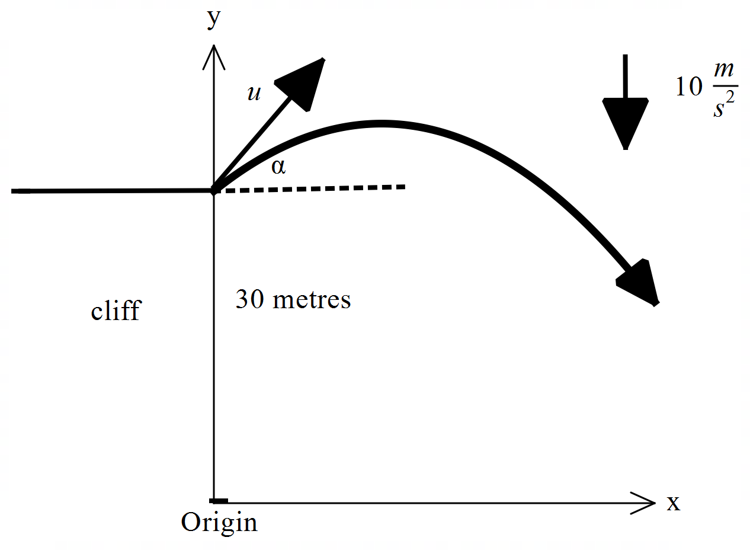

Let .
- Using vector integration, show how to derive the position vector at time seconds in terms of . Show all steps.

Solution
Specific behaviours
integrates acceleration with plus constant
solves for constant in terms of two variables
integrates velocity with plus constant
solves for constant and states r in terms of t
- Show how to derive the cartesian equation for the path of the particle in terms of .

Solution
Specific behaviours
expresses t in terms of x
subs into y parametric equation
states cartesian equation without any reference to t

- Set up an equation in terms of ONLY, but do not solve, that would allow the range
() to be determined where the particle hits the floor from the base of the cliff.

Solution
Specific behaviours
uses y=0
uses tan only with reference to angle in two terms of equation

Q4 (4 marks) (4.2.1)
If , determine in terms of only.

Solution
Specific behaviours
implicit diff of original equation
obtains expression for first derivative
implicit diff involving first derivative (or first implicit equation) shown
expression of second derivative in terms of x & y only, no need to simplify

Q5 (3 & 4 = 7 marks) (4.2.1)
Determine the following integrals:

Solution
Specific behaviours
changes to variable u and du
changes limits to u
obtains numerical value(unsimplfied)

Solution
Specific behaviours
expresses as two partial fractions with THREE constants
solves two constants
solves all three constants showing derivation for all
obtains expression for integral

Q6 (5 marks) (4.1.1, 4.2.2)
Consider a lighthouse that is 50 metres away from the shore. On the shore is a long brick wall. The light on the lighthouse is rotating at 4 revolutions per second. Determine the exact speed of the dot of light on the wall at a point 3 metres from the point directly opposite the lighthouse as shown below.

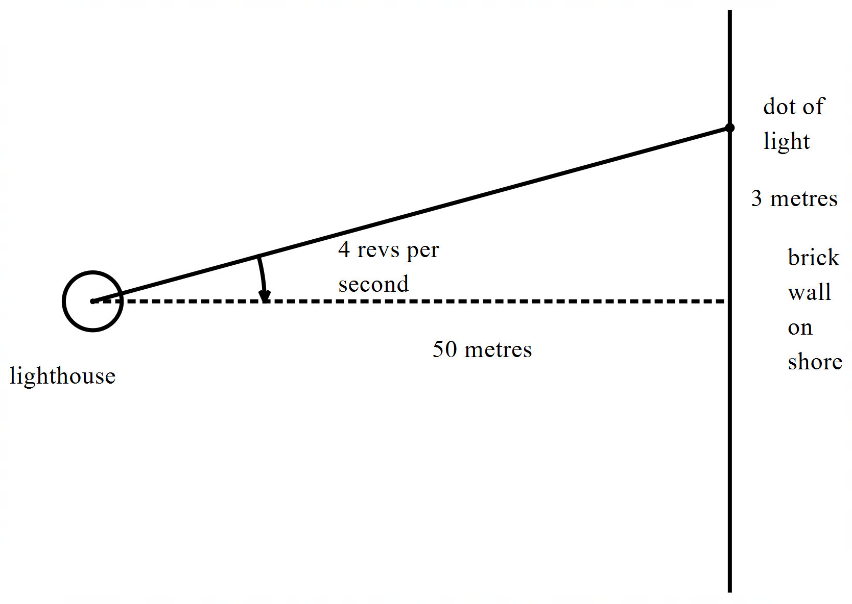

Solution
Specific behaviours
sets up equation between angle and distance along wall
determines rate of angle in radians
uses implicit diff or related rates to link all rates
determines exact value of tan of angle
states an exact expression of speed

